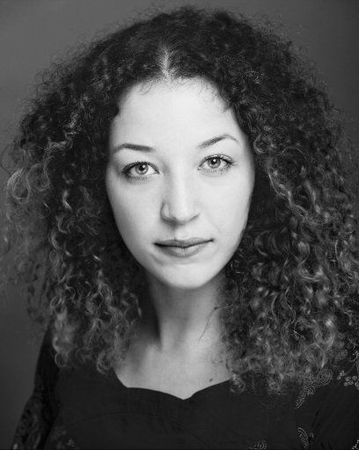
Rhiana Young
Mobile: 07854853585
Email: rhianayoung1@hotmail.com
Location: Northampton
Accents and Dialects: Wiltshire*, General American, General Australian
Stage Combat: Unarmed-Basic, Single Sword- Basic
Skills/Other: Swimming, Full Driver’s License, Passport

Height: 5’10”
Eye Colour: Green/Blue
Hair Colour: Brown/Blonde
Hair Length: Mid Length
Playing Age: 18-25

Year | Role | Production/Director | Company/Venue
2016  Upcoming | Miss Blake | BLUE STOCKINGS/Jamie Rocha Allan | The Royal and Derngate
2015 | Various | AN EVIL GATHERING OF INFIDELS/Kristoffer Huball | The University of Northampton
2015 | Fawcett | JERUSALEM/Laura Barnes | Gatecrash Theatre/Swindon Dance
2015 | Will/Various | FELIZ NAVIDAD! /Neil Archer | Malmesbury Abbey
2015 | Mopsa | THE WINTER’S TALE/Jamie Rocha Allan | The Royal and Derngate
2014 | William/Various | THE MALMESBURY NATIVITY/Robert Hinwood | Malmesbury Abbey
2013 | Mary Merryweather | JOHANNA’S MIRACLE GARDEN/Chris Garner | Sixth Sense Theatre Company/Lydiard Park
2011 | Caitlin (Lead) | IT SNOWS/Laura Street | Sixth Sense Theatre Company/Swindon Dance
Theatre Credits

Voice Credits
Year | Role | Production/Company
2014 | Commoner/Rich Aristocrat/Ballroom Lady (Voice Over) | THE GREAT FIRE/ITV

Training
2016 – BA (HONS) Acting, School of the Arts, Northampton
Additional Workshops
2015 – Frank Wurzinger, Clowning Workshop, The University of Northampton
2015 – Laura Susanne Hunt, Voice Workshop, The University of Northampton
2014 – Trudy Bell, Creative Acting, The University of Northampton
2014 – Christopher Simpson, Laban Technique, The University of Northampton
2014 – Sally Cook, Trestle Mask Workshop, The University of Northampton
2013 – Mary O’Brien, Musical Theatre Dance Workshop, The University of Northampton
2011 – Frantic Assembly Physical Theatre Workshop (Scott Graham), The Wyvern, Swindon

